Postoperative morbidity and mortality of defunctioning stoma in radical rectal cancer surgery: a systematic review and meta-analysis of proportions
Nikita Burlov^{1,2}, Vadim Shindyapin^{2,*}, Maksim Popov³, Artem Goncharov⁴, Vladislava S. Goncharova^{1,5}, Ilya Zorin⁶, Georgy I. Mashkov^{7,8}, Gleb N. Khrykov⁹, Ilya Chernikovskiy⁶
¹ Autonomous Non-Profit Organization "Scientific and Practical Club for the Development of Modern Medical Technologies", Moscow, Russian Federation.
² S.M. Kirov Military Medical Academy, Saint-Petersburg, Russian Federation.
² Sirius University of Science and Technology, Federal Territory Sirius, Russian Federation.
³ Republican Clinical Oncology Center, Russian Federation.
⁴ Central Clinical Hospital of the Administrative Directorate of the President of the Russian Federation, Moscow, Russian Federation.
⁵ Russian University of Medicine, Ministry of Health of the Russian Federation, 119991 Moscow, Russian Federation.
⁶ Moscow City Oncology Hospital No. 62, Moscow Department of Health, Moscow, Russian Federation.
⁷ Moscow Institute of Physics and Technology, School of Biological and Medical Physics, 9/7 Institutskiy Pereulok, Dolgoprudny, Moscow Region, 141701, Russian Federation.
⁸ I.M. Sechenov First Moscow State Medical University (Sechenov University), 8/2 Trubetskaya Street, Moscow, 119048, Russian Federation.
⁹ Research Institute of Clinical Oncology, Nizhny Novgorod Regional Clinical Oncology Dispensary, 190 Rodionova Street, Nizhny Novgorod, 603093, Russian Federation.
* Corresponding author: !!!!!!!!!!!!!!!!
ORCID: N.B. 0000-0003-3407-4406; V.S. 0009-0006-3165-6872; M.P. 0009-0002-0468-1221; A.G. 0000-0002-1326-7893; V.S.G. 0009-0001-2545-1911; I.Z. 0000-0002-1621-7015; G.M. 0009-0001-0612-4456, G.N.K. 0000-0002-0249-4759; I.C. 0000-0002-8791-9241.
Abstract
A defunctioning loop stoma is formed routinely during sphincter-preserving rectal cancer surgery to blunt the consequences of anastomotic leakage, yet the absolute risk carried by the diverted patient has not been quantified across contemporary practice. We systematically searched MEDLINE/PubMed and the Cochrane Database of Systematic Reviews from 1 January 1982 to 4 April 2026 and pooled proportions from 74 studies using random-effects generalised linear mixed models with a logit link. Among 26,534 patients, clinically relevant anastomotic leakage occurred in 7.12% (95% CI 6.03–8.40), and 30-day mortality in 18,189 patients was 0.91% (0.60–1.38). Overall 30-day morbidity reached 32.85% (27.37–38.84) and Clavien–Dindo grade IIIa or higher complications 7.61% (4.90–11.64). Heterogeneity was high throughout (I² 87–94%), and prediction intervals were correspondingly wide. Leakage did not differ by stoma composition, study design or publication era. Diversion does not abolish leakage: roughly one diverted patient in fourteen still leaks and one in three sustains a complication within 30 days, which argues for selective rather than reflexive diversion and for standardised outcome reporting.
Keywords: rectal neoplasms; defunctioning stoma; loop ileostomy; anastomotic leak; postoperative complications; meta-analysis of proportions
Introduction
Colorectal cancer is among the most frequently diagnosed malignancies and a leading cause of cancer death worldwide, and the rectum accounts for a substantial and separately reported share of that burden [1]. For localised and locally advanced disease, elective radical resection along the mesorectal plane, introduced by Heald and colleagues in the 1980s [2,3], remains the curative-intent standard, and current European, North American and consensus guidelines recommend sphincter-preserving anterior or low anterior resection with total mesorectal excision whenever the tumour permits an oncologically adequate distal margin and acceptable residual function [4–6]. Restoring intestinal continuity therefore leaves an anastomosis in the deep pelvis, and the fate of that anastomosis dominates early postoperative outcome.
Anastomotic leakage, as defined by the International Study Group of Rectal Cancer [7], is the complication that determines much of what follows. Reported incidence depends heavily on definition, case-mix and completeness of ascertainment: a systematic review applying the ISREC grading to 24,288 anterior resections found an overall leak rate of 8.58%, with grade C leaks requiring relaparotomy in 5.40% [8]; a pooled analysis of five European randomised trials reported symptomatic leakage in 9.7% of 2,726 low anterior resections [11]; a meta-analysis of 18,039 patients reported 9.8% [9]; and a multicentre observational series with prospective audit reported 14.8% [10]. The consequences are consistent across these datasets. Thirty-day mortality rose from 1.2% to 4.3% in the audit cohort [10] and from 1.3% to 5.7% in the trial pooling [11], and leakage was associated with higher local recurrence (odds ratio 1.50, 95% CI 1.23–1.82) and worse overall (OR 0.69, 95% CI 0.60–0.81) and disease-free survival (OR 0.51, 95% CI 0.36–0.73) [9].
Faecal diversion is the principal manoeuvre used against this. A Swedish multicentre randomised trial of 234 patients undergoing low anterior resection showed that a defunctioning loop stoma reduces symptomatic leakage and the reoperations it provokes [12], and successive syntheses have reproduced the effect: clinically relevant leakage OR 0.32 (95% CI 0.17–0.59) and reoperation OR 0.27 (95% CI 0.14–0.51) in a mixed-design meta-analysis [13]; risk ratios of 0.39 and 0.29 respectively in the randomised subset of a design-stratified analysis [14]; and, restricting to eight randomised trials of 892 patients, leakage 6.3% versus 18.3% (RR 0.36, 95% CI 0.24–0.54) and reoperation 5.9% versus 16.7% (RR 0.40, 95% CI 0.26–0.60) [15]. On this evidence, proximal diversion has become close to routine for low pelvic anastomoses.
The stoma is not, however, a free intervention, and its cost is paid by every diverted patient rather than only by those who would have leaked. A review of 18 randomised trials reported all-cause stoma complication rates with a median of 14.3% for loop ileostomy and 26.3% for loop colostomy [16]. Reversal carries its own morbidity of 17.3% and mortality of 0.4% across 6,107 closures [17], and a proportion of stomas is never closed: a Swedish population-based cohort put the permanent stoma rate after anterior resection at 13.6% and 15.2% in its derivation and validation sets [18]. Existing quantitative syntheses do not describe this burden in the terms a surgeon needs at the point of consent. They answer comparative questions, stoma versus no stoma [13–15] or loop ileostomy versus loop colostomy [19,20], and therefore report relative effects within selected comparative cohorts. What is missing is the absolute, contemporary risk of morbidity and early death in the population that actually receives a defunctioning stoma, drawn from the whole eligible literature including single-arm institutional series and registry-based cohorts.
A second gap is methodological. Much of the proportion-pooling literature in this field relies on the Freeman–Tukey double arcsine transformation, whose inverse can return seriously misleading pooled estimates when event rates are low and study sizes unbalanced [21,22]; the point remains contested [23,24], but the recommended alternative is to model the binomial likelihood directly with a generalised linear mixed model on the logit scale [25]. We therefore undertook a systematic review and random-effects meta-analysis of proportions, using a logit-link generalised linear mixed model, to estimate the pooled prevalence of postoperative morbidity and short-term mortality in adults receiving a defunctioning loop stoma at the time of radical sphincter-preserving resection for rectal cancer, with prespecified subgroup analyses by stoma type, study design and publication era.
Results
Study selection
Database searching identified 1,323 records. After removal of 387 duplicates and 78 records rejected by automation tools, 858 records were screened, of which 613 were excluded on title and abstract. Of 245 reports sought for retrieval, one could not be obtained, leaving 244 assessed in full text. Full-text exclusions comprised 37 reports in which patients with stage IV disease exceeded 5% of the cohort, 29 in which emergency operations exceeded 5%, and 90 excluded for other reasons, namely fewer than 50 eligible patients, absence of total mesorectal excision, or outcome data that could not be disaggregated for the eligible subgroup. Seventy-two studies were included in the review and all 74 contributed to the meta-analysis (Fig. 1). Included designs were 4 randomised controlled trials, 5 prospective cohorts and 65 retrospective cohorts. Not every study reported every outcome, so the number of contributing studies and patients differs between analyses and is given separately for each (Table 1).
Risk of bias
Among the four randomised trials, two were judged at low overall risk of bias and two raised some concerns (Fig. 2a,b). Concerns arose in the domain of deviations from the intended intervention in two trials, reflecting the impossibility of blinding stoma formation, and in outcome measurement and selection of the reported result in the earliest trial. No trial was judged at high risk of bias in any domain. Newcastle–Ottawa total scores for the non-randomised studies ranged from 4 to 9 of a maximum 9, with a median of 7 (Fig. 2c). Losses were concentrated in the comparability domain, which many single-arm and registry reports cannot satisfy by design, rather than in selection or outcome ascertainment. [[AUTHORS: insert the exact number and percentage of non-randomised studies scoring ≥7 from the extraction file; the per-study scores are shown in Fig. 2c.]]
Anastomotic leakage
Sixty-six estimates from the included studies reported clinically relevant anastomotic leakage in 2,443 of 26,534 patients. The pooled prevalence was 7.12% (95% CI 6.03–8.40), with substantial heterogeneity (I² 87.3%, 95% CI 84.6–89.6; τ² 0.409; p < 0.0001) and a 95% prediction interval of 2.07% to 21.78% (Fig. 3). Study-specific estimates spanned an order of magnitude, from 1.34% to 28.00%, and the width of the prediction interval indicates that the pooled value should not be read as the risk expected in any individual centre.
Prespecified subgroup analyses did not explain this dispersion. Leakage was 7.12% (5.69–8.87) in the 41 estimates confined to loop ileostomy and 7.31% (5.54–9.59) in the 25 estimates from cohorts containing both ileostomies and colostomies (p_{subgroup test} = 0.8776; Supplementary Fig. S1). By design, leakage was 7.01% (5.85–8.38) in retrospective cohorts, 10.33% (4.99–20.17) in prospective cohorts and 5.47% (2.27–12.62) in randomised trials (p_{subgroup test} = 0.2162; Supplementary Fig. S2). By publication era, leakage was 7.69% (4.79–12.13) before 2010, 7.97% (6.30–10.03) between 2010 and 2019, and 6.19% (4.63–8.21) from 2020 onwards (p_{subgroup test} = 0.3547; Supplementary Fig. S3). Heterogeneity remained above 80% within every subgroup, so none of these stratifications identifies the source of between-study variation. No cohort reported loop colostomy in isolation, and the subgroup analysis by surgical approach specified in the protocol could not be performed because approach was reported too inconsistently to classify cohorts.
Re-analysis using the broadest leak definition reported by each study, which added two further cohorts and reclassified one, gave 7.29% (6.11–8.68) in 2,484 of 26,919 patients with unchanged heterogeneity (I² 88.4%; τ² 0.484) and did not alter any subgroup comparison (Supplementary Figs S4–S6). The pooled estimate is therefore robust to the choice between a clinically relevant and an all-inclusive leak definition.
Mortality
Twenty estimates reported 30-day mortality in 478 of 18,189 patients. The pooled prevalence was 0.91% (95% CI 0.60–1.38), with high heterogeneity (I² 92.3%, 95% CI 89.6–94.4; τ² 0.400; p < 0.0001) and a prediction interval of 0.23% to 3.57% (Fig. 4). Most cohorts clustered between 0.16% and 1.59%; the single outlying estimate of 5.30% came from the largest contributing dataset, a registry-based cohort of 7,148 patients, and its weight explains much of the observed inconsistency.
Morbidity
Twenty-eight estimates reported any complication within 30 days in 2,974 of 9,555 patients, giving a pooled prevalence of 32.85% (95% CI 27.37–38.84) with I² 94.4% (92.9–95.5), τ² 0.436 and a prediction interval of 10.97% to 66.02% (Fig. 5a). Study-specific values ranged from 14.08% to 80.49%. Twenty-two estimates reported severe complications, defined as Clavien–Dindo grade IIIa or higher, in 518 of 4,635 patients, giving 7.61% (4.90–11.64) with I² 87.8% (82.9–91.3), τ² 0.969 and a prediction interval of 0.99% to 40.36% (Fig. 5b). The gap between overall and severe morbidity indicates that roughly three-quarters of recorded complications did not require intervention under general anaesthesia, intensive care or cause death, although the variance of the severe-complication estimate was the largest of any outcome analysed.
Of the remaining prespecified secondary outcomes, surgical site infection, unplanned reoperation and unplanned readmission within 30 days were reported too inconsistently across the eligible cohorts to support pooling, and length of hospital stay was not pooled by design. [[AUTHORS: confirm this statement and, if any of these three outcomes was in fact pooled, supply the forest plot and the pooled estimate so it can be added to Table 1.]]
Small-study effects and sensitivity analyses
The funnel plot for anastomotic leakage was asymmetric, with a deficit of small studies reporting high leak rates (Fig. 6a). Restricting the analysis to cohorts of at least 150 patients reduced but did not remove the asymmetry (Fig. 6b). Trim-and-fill imputed a substantial number of missing studies on the right-hand side of the distribution (Fig. 6c), indicating that the pooled leak estimate is more likely to be conservative than inflated. The funnel plot for 30-day mortality showed a comparable pattern (Fig. 6d). Given that all outcomes exceeded the conventional threshold of substantial inconsistency, leave-one-out analysis was performed for each and no single study altered any pooled estimate beyond its confidence interval. [[AUTHORS: supply Egger's regression test statistics and p-values, and the trim-and-fill adjusted estimate with the number of imputed studies, for anastomotic leakage and 30-day mortality; these numbers are needed to replace the qualitative wording above.]]
Certainty of evidence
Certainty was rated very low for all four pooled outcomes. The evidence base is dominated by non-randomised cohorts, which carries a serious risk of bias for an absolute-risk question; inconsistency was very serious for every outcome, with I² above 87% and prediction intervals spanning ranges that would support opposite clinical conclusions; and funnel asymmetry raised suspicion of publication bias for leakage and mortality. Imprecision was not a limiting factor given the sample sizes involved (Table 1).
Discussion
Across 72 studies and up to 26,534 patients, the diverted patient undergoing radical sphincter-preserving rectal cancer surgery still faces a 7.12% risk of clinically relevant anastomotic leakage, a 0.91% risk of death within 30 days, a 32.85% risk of any complication and a 7.61% risk of a complication requiring intervention, intensive care or proving fatal. The central message is what the leak figure does not show. Diversion is performed in the expectation that it protects the anastomosis, and randomised evidence supports a relative reduction in symptomatic leakage [12–15]. Yet the absolute leak rate in a fully diverted population is not materially lower than the rates reported from unselected and largely undiverted series: 8.58% in 24,288 anterior resections graded by ISREC criteria [8], 9.7% in a pooled analysis of five randomised trials [11] and 9.8% across 18,039 patients [9]. The nationwide RALAR cohort of 5,398 anterior resections reached the same conclusion from individual patient data, reporting an overall leak rate of 10.2% and finding that the stoma did not reduce the leak rate but did reduce leak severity and the reoperation rate [26]. A stoma reduces the consequences of leakage more reliably than it prevents the leak, and roughly one diverted patient in fourteen leaks despite the stoma.
Two further findings deserve emphasis. First, the leak estimate was unmoved by stoma composition, study design and publication era, with every subgroup contrast far from significance and heterogeneity above 80% within every stratum. Twenty years of technical change has not translated into a demonstrable fall in the pooled leak rate: the point estimate for studies published from 2020 onwards, 6.19%, overlaps completely with the pre-2010 estimate of 7.69%. That flat trajectory is consistent with the contemporary literature on newer platforms. A meta-analysis of proportions across 41 transanal total mesorectal excision series and 2,446 patients returned a pooled leak rate of 6.8% (95% CI 5.2–8.9) and pooled morbidity of 30.0% (26.4–34.0) [27], values that sit almost exactly on the estimates reported here, and the REAL randomised trial found that a robotic platform lowered Clavien–Dindo grade II or higher complications from 23.1% to 16.2% without eliminating them [28]. Since surgical approach could not be classified consistently in the present dataset, this review cannot attribute the absence of a temporal trend to any specific factor, and the possibility that case-mix has shifted toward more difficult tumours while technique improved cannot be excluded. Second, 30-day mortality at 0.91% is reassuringly low and considerably below the 4.3% to 5.7% reported in patients who do leak [10,11], which is consistent with diversion converting a potentially lethal event into a manageable one. The consequences of leakage extend well past 30 days: in the TENTACLE-Rectum cohort of 2,499 patients with leakage from 216 centres, only 45.0% were stoma-free one year later [29], and a synthesis of 35 studies and 44,698 patients linked leakage to local recurrence (OR 1.93, 95% CI 1.57–2.38), worse overall survival (OR 1.64, 1.37–1.95) and worse disease-free survival (OR 2.07, 1.50–2.87) [30]. What is being averted is therefore not only a perioperative event.
The morbidity estimates frame the trade-off that consent should describe. One in three diverted patients sustains a complication within 30 days, against a background in which stoma-specific morbidity has a median of 14.3% for loop ileostomy [16], closure adds 17.3% morbidity and 0.4% mortality [17], and 13.6% to 15.2% of stomas are never reversed [18]. Much of the burden aggregated inside the 32.85% figure is renal and fluid-related rather than septic. Acute kidney injury complicated 19.4% of index admissions after ileostomy formation in a consecutive series of 262 patients, and 11% of that cohort were readmitted with dehydration [31]; in the Swedish Colorectal Cancer Registry, five-year renal failure was 7.2% with a defunctioning stoma against 3.3% without, with a weighted hazard ratio at one year of 11.59 (95% CI 5.68–23.65) [32]. A meta-analysis of 10 studies and 2,036 patients confirms that this liability is specific to the ileostomy, which carried almost three times the risk of dehydration and electrolyte disturbance of a loop colostomy (RR 2.98, 95% CI 1.51–5.89) while avoiding prolapse and retraction [33]. The functional cost accrues over years: pooled across 50 studies, major low anterior resection syndrome affects 44% of patients, and a defunctioning stoma was an independent risk factor with an OR of 1.89 (95% CI 1.58–2.27) and no heterogeneity between studies [34]. In the EASY trial, a permanent stoma was present in 6 of the late-closure group against 1 after early closure [35]. Weighed against a leak risk that remains above 7% with the stoma in place, these figures make a case for selective rather than reflexive diversion.
Selection is now technically possible. A risk score developed in 2,727 Swedish patients meeting the criteria of the SELSA trial, in whom leakage occurred in 7.3%, retained male sex (OR 2.00, 95% CI 1.45–2.75), obesity (OR 1.82, 1.21–2.74) and radiotherapy (OR 1.90, 1.35–2.69), and is being used prospectively to randomise patients below a 10% predicted risk to no defunctioning stoma [36]. Practice has not yet followed: among 1,019 surgeons surveyed internationally, decisions in low and moderate risk patients were most often described as influenced by personal experience rather than by any model [37]. The adjuncts proposed as substitutes for diversion perform inconsistently. The IntAct randomised trial found clinically relevant leakage in 10% with indocyanine green fluorescence angiography against 15% with standard care, a difference that did not reach significance (adjusted OR 0.667, 95% CI 0.419–1.060) [38], whereas a meta-analysis of nine randomised trials and 4,754 patients found an overall reduction (RR 0.66, 95% CI 0.56–0.78) concentrated in low anterior resection, where the number needed to treat was 13 [39]. Ghost ileostomy avoided a stoma in most patients without altering leak rates or overall morbidity across 14 studies and 946 patients, but ISREC grade C leaks accounted for 19.1% of leaks in the ghost group and none in the loop ileostomy group [40]. None of these options removes the risk quantified here; each redistributes it.
The comparison with existing syntheses is where the methodological contribution sits. Previous meta-analyses in this field are comparative and therefore report relative effects conditional on inclusion in a comparative cohort [13–15,19,20]. By pooling proportions across the whole eligible literature, including registry and single-arm series, this review yields the quantity a surgeon needs at the bedside, an absolute risk, and does so with a logit-link generalised linear mixed model that models the binomial likelihood directly rather than relying on the Freeman–Tukey double arcsine transformation, whose back-transformation can distort pooled proportions when events are sparse and study sizes unbalanced [21,22,25]. Reporting prediction intervals alongside confidence intervals is a deliberate part of that approach. Across 479 significant Cochrane meta-analyses with heterogeneity, the prediction interval admitted a null or reversed effect in 72.4% of cases [41], and in a review of 134 prevalence syntheses the median I² was 96.9% while only 2% reported a prediction interval, which is why I² thresholds are a poor guide to the credibility of a pooled proportion [42]. The price of this approach is that no absolute-risk synthesis can support a causal claim about the effect of diversion, and none is made here.
Several limitations bound the conclusions. Heterogeneity was very high for every outcome, so the prediction intervals rather than the confidence intervals describe what a new centre should expect: 2.07% to 21.78% for leakage and 10.97% to 66.02% for overall morbidity. Much of this dispersion is definitional. Studies differ in whether radiologically detected asymptomatic leaks are counted, whether complications are captured prospectively or from discharge coding, and whether follow-up truly extends to 30 days, and the subgroup analyses show that these differences are not captured by stoma type, design or era. The transanal synthesis quantified the same effect directly, reporting morbidity of 35.5% in studies with explicit 30-day follow-up against 23.4% where follow-up length was undefined (p = 0.003) [27]. The evidence base is predominantly retrospective, with only 4 randomised trials and 611 randomised patients, and the median Newcastle–Ottawa score of 7 reflects cohorts that are adequately selected and followed but frequently non-comparable by design. Funnel asymmetry and the trim-and-fill result suggest that cohorts with high leak rates are under-represented, so the true population leak rate may exceed 7.12%. Full-text eligibility was restricted to English-language reports, the requirement for at least 50 eligible patients excludes small series, and the prespecified analyses of surgical approach and of infection, reoperation and readmission could not be completed because the primary literature does not report these items consistently enough. That reporting gap is itself a finding: a field that forms hundreds of thousands of defunctioning stomas annually cannot currently produce comparable estimates of their infectious or reintervention burden. The CoReAL framework, a modified Delphi consensus that fixed 33 statements and 43 reporting elements for anastomotic leakage after colorectal cancer surgery [43], provides the instrument; applying it prospectively, with explicit 30-day ascertainment and Clavien–Dindo grading, would remove most of the dispersion documented here.
In summary, defunctioning diversion in radical rectal cancer surgery is associated with a low risk of early death but a leak rate above 7% and a 30-day complication rate near one in three, with dispersion so wide that pooled point estimates cannot substitute for local audit. These absolute risks, rather than relative reductions, are the numbers that belong in a consent discussion and in the design of trials testing selective diversion.
Methods
Protocol, registration and reporting
The review was designed and conducted in accordance with a protocol registered prospectively in PROSPERO CRD420261422080, submitted 6 July 2026, registered 7 July 2026, version 1.0). Reporting follows the PRISMA 2020 statement [44], and the completed checklist is provided as Supplementary Table S1. Before registration the protocol, including the PICO framework, eligibility criteria, search strategies and risk-of-bias plan, was reviewed by an external content expert in colorectal surgery not otherwise involved in the review; recommendations to expand the stoma-related controlled vocabulary and to clarify the comparator structure were incorporated, and no comment was rejected without a documented rationale. Deviations from the registered protocol are listed at the end of this section. The review analysed only aggregate data from previously published reports; no new experiments on human participants, human tissue or animals were undertaken, no identifiable patient information was collected, and institutional ethics approval and individual informed consent were therefore not applicable.
Eligibility criteria
Eligible participants were adults aged 18 years or older with histologically confirmed rectal adenocarcinoma, localised or locally advanced (TNM stage I–III, or M0 where TNM was not reported), undergoing elective radical sphincter-preserving surgery with simultaneous creation of a defunctioning loop stoma and a colorectal or coloanal anastomosis at the same operation. Studies were eligible when at least one arm or a clearly defined subgroup met these criteria. We excluded non-adenocarcinoma rectal pathology, anal canal cancer, benign and non-oncological indications, metastatic or oligometastatic disease at the index operation, emergency surgery, and palliative or purely endoscopic procedures unless a curative-intent surgical subgroup was reported separately. Cohorts in which patients with stage IV disease or emergency operations exceeded 5% were excluded at full text.
The eligible intervention was elective anterior or low anterior resection with total mesorectal excision, including intersphincteric resection and other sphincter-preserving variants, with simultaneous formation of a defunctioning loop ileostomy or loop colostomy and a primary anastomosis. All operative approaches were eligible. Operations with and without neoadjuvant chemoradiotherapy or short-course radiotherapy were eligible, and enhanced recovery pathways were recorded but not used as an eligibility criterion. We excluded delayed or staged stoma formation, permanent end stomas, ghost or virtual ileostomy, Hartmann's procedure and other resections without a primary anastomosis, abdominoperineal resection, operations without rectal resection, stoma closure as the principal intervention, and stomas created reactively for an established leak.
Because the target of inference is an absolute prevalence, non-comparative studies required no internal comparator. Where comparative data existed, two prespecified contrasts informed subgroup analysis: stoma type and study design. Studies whose only comparator was a historical or external control, or in which groups were defined post hoc by the occurrence of leakage, were excluded.
Randomised controlled trials, non-randomised comparative studies, prospective and retrospective cohorts, registry and population-based analyses, and single-arm series were all eligible. Records in any language were considered at title and abstract screening; full-text assessment and data extraction were restricted to reports published in English. Studies contributing fewer than 50 eligible patients were excluded, as were studies in which the eligible subgroup could not be sized or its outcome data disaggregated, studies using matching at the sampling stage, studies applying propensity-score matching without reporting unmatched descriptive statistics, and case–control studies, case reports, narrative reviews and previous systematic reviews. To contribute to quantitative synthesis a study had to report both numerator and denominator for at least one prespecified outcome. Any clinical setting in which elective radical sphincter-preserving rectal cancer surgery is routinely performed was eligible, with no geographical restriction.
Information sources and search strategy
MEDLINE/PubMed and the Cochrane Database of Systematic Reviews were searched for records published from 1 January 1982, the year in which the mesorectal plane was first described as the determinant of pelvic recurrence [2], to 4 April 2026. Only published studies were sought; no grey-literature, trial-registry or citation-tracking supplements were used, and study authors were not contacted.
Two search strategies were developed independently and in parallel by two reviewers (V.S. and N.B.), each combining controlled vocabulary and free-text title and abstract terms across three conceptual blocks: rectal neoplasms; sphincter-preserving rectal resection with total mesorectal excision; and any proximal defunctioning stoma. Publication-type exclusions removed reviews, meta-analyses, editorials, letters, comments and case reports, and title-level exclusions removed reports focused on stoma closure or reversal, low anterior resection syndrome, cost-effectiveness, quality of life, stoma care, microbiome, body image, psychological outcomes, palliative or paediatric populations, and permanent stoma. Human and English-language filters were applied. Both strategies were audited against the PRESS 2015 checklist [45] and returned 614 and 209 records respectively when executed in PubMed on 4 April 2026. Records were exported to Zotero in RIS format and deduplicated automatically with manual verification of near-duplicates. In total 1,323 records were retrieved from the databases searched, of which 387 were duplicates and 78 were rejected by automation tools before screening (Fig. 1). The full Boolean syntax of both strategies is reproduced in Supplementary Table S2. Пчоему 1300 и 823??????????
Study selection and data extraction
Title and abstract screening and full-text eligibility assessment were performed independently and in duplicate by two reviewers (M.P. and I.Z.) using structured templates, with reviewers blinded to each other's decisions until conflict resolution. Disagreements were resolved by discussion, and persistent disagreements were adjudicated by a senior arbitrator (A.G.). Reasons for exclusion at full text were recorded and are presented in Fig. 1. Data were extracted independently and in duplicate into a piloted form covering bibliographic details and publication type; country; study design, centre status and recruitment period; number of eligible patients; demographic and tumour characteristics where reported; operative approach and type of resection; stoma type; use of neoadjuvant therapy; the definition and grading system used for each outcome; duration of follow-up; and the numerator and denominator for every prespecified outcome. Discrepancies were resolved by discussion and arbitration as above.
Outcomes and definitions
Two co-primary outcomes were prespecified. The first was anastomotic leakage within 30 days, defined according to the ISREC consensus as a defect of intestinal wall integrity at the anastomotic site producing communication between the intraluminal and extraluminal compartments, with an adjacent pelvic abscess also counted as leakage [7]. The primary estimate combines clinically relevant leaks corresponding to ISREC grades B and C; a sensitivity analysis used the broadest leak definition reported by each study. The second co-primary outcome was 30-day all-cause postoperative mortality, with deaths occurring later during the same uninterrupted acute-care admission also captured.
Secondary outcomes were overall postoperative complications within 30 days, defined as any deviation from the normal postoperative course of Clavien–Dindo grade I or higher [46]; severe complications, defined as Clavien–Dindo grade IIIa or higher; surgical site infection within 30 days as defined by the CDC/NHSN criteria [47]; unplanned reoperation within 30 days related to the index resection; and unplanned readmission within 30 days of discharge. Length of hospital stay was recorded but not pooled, because discharge criteria, health-system context and the frequent absence of dispersion measures make a pooled central estimate uninterpretable.
Risk of bias and certainty of evidence
Risk of bias in randomised trials was assessed with the Cochrane RoB 2 tool [48] and in non-randomised studies with the Newcastle–Ottawa Scale, independently and in duplicate by two reviewers (G.I.M. and G.N.K.), with disagreements resolved by discussion. Risk of bias arising from missing results within studies was not formally assessed, in line with the registered protocol. Certainty of the body of evidence was rated for each outcome using the GRADE approach [49,50] and is reported in Table 1; because every pooled outcome is an absolute prevalence derived predominantly from non-randomised cohorts, the starting point for rating was low certainty, with further downgrading for inconsistency and suspected publication bias as applicable.
Statistical analysis
Analyses were performed in R version 4.4 or later with the packages meta [51] and metafor [52]. For each dichotomous outcome the pooled prevalence was estimated with a random-effects generalised linear mixed model with a logit link and study-level random intercepts [25], which models the within-study binomial distribution exactly and avoids the back-transformation behaviour that makes the inverse Freeman–Tukey double arcsine transformation unreliable for sparse events and unbalanced study sizes [21,22]. Between-study variance τ² was estimated by maximum likelihood, and estimates were back-transformed and reported as pooled prevalence with 95% confidence intervals. Where a study reported outcomes separately for distinct stoma types or cohorts, each was entered as a separate estimate and labelled accordingly, so the number of estimates can exceed the number of studies.
Heterogeneity was quantified by τ² and by I² with 95% confidence intervals [53,54] and interpreted against the thresholds in the Cochrane Handbook [55]. Because heterogeneity was anticipated to be substantial for absolute-risk outcomes, 95% prediction intervals were computed for every pooled estimate and are reported alongside the confidence intervals. Subgroup analyses were prespecified for stoma type, study design and publication era (before 2010, 2010–2019, and 2020 onwards), with between-subgroup differences tested by the Q statistic. Small-study effects were assessed by funnel-plot inspection, by Egger's regression test for funnel-plot asymmetry [57], by restriction to cohorts of at least 150 patients, and by the trim-and-fill method [56]. Leave-one-out analysis was performed for each outcome with I² above 75%. Outcomes for which the primary reports did not provide compatible numerators and denominators were not pooled and are described narratively, following the SWiM reporting guideline [58].

Study characteristics and outcome rates were first summarized descriptively. Continuous variables are reported as mean (SD), median [Q1, Q3] and range; categorical variables as counts and percentages.
For each outcome (anastomotic leak, overall or severe postoperative complications, mortality), event counts and sample sizes were analyzed using a generalized linear mixed-effects model (GLMM) with a binomial likelihood, logit link, and random study-level intercept [Schwarzer, Carpenter, and Rücker, 2015].
A random-effects model was used throughout, with τ2 estimated by maximum likelihood [Viechtbauer, 2005]. Confidence intervals were based on the Knapp-Hartung approach for standard random-effects meta-analysis [Knapp and Hartung, 2003]. Heterogeneity was reported as Cochran’s Q, I2 (with 95% CI) and τ2 [Higgins and Thompson, 2002], together with a 95% prediction interval for each pooled estimate, calculated with the Higgins-Thompson-Spiegelhalter method [Higgins, Thompson, and Spiegelhalter, 2009].
For the anastomotic leak outcome, prespecified subgroup analyses were run by stoma type (ileostomy vs. combined ileostomy/colostomy; colostomy alone included only two studies and was not analyzed separately), study design (retrospective cohort, prospective cohort, RCT) and publication period (<2010, 2010-2019, ≥2020). Each subgroup was pooled with the same random-effects GLMM, τ2 was estimated separately per subgroup, and differences between subgroups were assessed using a Q-test for subgroup differences [Borenstein and Higgins, 2013].
Small-study effects were assessed visually using funnel plots and formally using Peters’ regression test [Peters et al., 2006]. As a sensitivity analysis, the Duval and Tweedie trim-and-fill method [Duval and Tweedie, 2000] was used to estimate the pooled effect after imputing studies that would restore funnel-plot symmetry; given the substantial heterogeneity, these results were interpreted cautiously. The GLMM estimate was compared with a conventional inverse-variance random-effects meta-analysis of logit-transformed proportions.
All analyses were performed in R version 4.6.1, using RStudio version 2026.07.1, with the meta [Balduzzi, Rücker, and Schwarzer, 2019], metafor [Viechtbauer, 2010] and dmetar [Harrer et al., 2021] packages (N.B.).
Deviations from the registered protocol
Four deviations are declared. First, the protocol both stated that no minimum cohort size would be imposed a priori and excluded studies with fewer than 50 eligible patients; the 50-patient rule was applied, and cohorts in which stage IV disease or emergency operations exceeded 5% were additionally excluded at full text as an operational refinement of the registered population criteria. Second, the protocol announced six secondary outcomes and enumerated five; the five enumerated outcomes plus length of hospital stay are treated as the secondary outcome set, of which overall and severe complications could be pooled. Third, the prespecified subgroup analysis by surgical approach was not performed because approach was reported too inconsistently to classify cohorts, and no cohort reported loop colostomy in isolation, so the stoma-type subgroup compares ileostomy-only cohorts against mixed cohorts rather than ileostomy against colostomy. Fourth, meta-regression on study-level covariates was not performed because age, sex distribution, proportion of minimally invasive procedures and use of neoadjuvant therapy were reported too inconsistently to model. [[AUTHORS: confirm each of these four statements, and add any further deviation with its timing and rationale.]]
Data Availability
All data supporting the findings of this study are contained within the article and its Supplementary Information. The complete search strategies, the list of studies excluded at full text with reasons, the extracted study-level dataset and the analysis code are available at РЕПОЗИТОРИЙ. The registered protocol is publicly available from PROSPERO CRD420261422080. No individual participant data were obtained or analysed.
References
1. Bray, F. et al. Global cancer statistics 2022: GLOBOCAN estimates of incidence and mortality worldwide for 36 cancers in 185 countries. CA Cancer J. Clin. 74, 229–263 (2024). https://doi.org/10.3322/caac.21834
2. Heald, R. J., Husband, E. M. & Ryall, R. D. The mesorectum in rectal cancer surgery: the clue to pelvic recurrence? Br. J. Surg. 69, 613–616 (1982). https://doi.org/10.1002/bjs.1800691019
3. Heald, R. J. & Ryall, R. D. Recurrence and survival after total mesorectal excision for rectal cancer. Lancet 1, 1479–1482 (1986). https://doi.org/10.1016/S0140-6736(86
4. Glynne-Jones, R. et al. Rectal cancer: ESMO Clinical Practice Guidelines for diagnosis, treatment and follow-up. Ann. Oncol. 28, iv22–iv40 (2017). https://doi.org/10.1093/annonc/mdx224
5. You, Y. N. et al. The American Society of Colon and Rectal Surgeons clinical practice guidelines for the management of rectal cancer. Dis. Colon Rectum 63, 1191–1222 (2020). https://doi.org/10.1097/DCR.0000000000001762
6. Benson, A. B. et al. NCCN Guidelines Insights: rectal cancer, version 3.2024. J. Natl Compr. Canc. Netw. 22, 366–375 (2024). https://doi.org/10.6004/jnccn.2024.0041
7. Rahbari, N. N. et al. Definition and grading of anastomotic leakage following anterior resection of the rectum: a proposal by the International Study Group of Rectal Cancer. Surgery 147, 339–351 (2010). https://doi.org/10.1016/j.surg.2009.10.012
8. Cong, Z. J. et al. Systematic review of anastomotic leakage rate according to an international grading system following anterior resection for rectal cancer. PLoS ONE 8, e75519 (2013). https://doi.org/10.1371/journal.pone.0075519
9. Karim, A. et al. Anastomotic leak and cancer-specific outcomes after curative rectal cancer surgery: a systematic review and meta-analysis. Tech. Coloproctol. 24, 513–525 (2020). https://doi.org/10.1007/s10151-020-02153-5
10. Ptok, H. et al. Impact of anastomotic leakage on oncological outcome after rectal cancer resection. Br. J. Surg. 94, 1548–1554 (2007). https://doi.org/10.1002/bjs.5707
11. den Dulk, M. et al. Multicentre analysis of oncological and survival outcomes following anastomotic leakage after rectal cancer surgery. Br. J. Surg. 96, 1066–1075 (2009). https://doi.org/10.1002/bjs.6694
12. Matthiessen, P., Hallböök, O., Rutegård, J., Simert, G. & Sjödahl, R. Defunctioning stoma reduces symptomatic anastomotic leakage after low anterior resection of the rectum for cancer: a randomized multicenter trial. Ann. Surg. 246, 207–214 (2007). https://doi.org/10.1097/SLA.0b013e3180603024
13. Hüser, N. et al. Systematic review and meta-analysis of the role of defunctioning stoma in low rectal cancer surgery. Ann. Surg. 248, 52–60 (2008). https://doi.org/10.1097/SLA.0b013e318176bf65
14. Tan, W. S., Tang, C. L., Shi, L. & Eu, K. W. Meta-analysis of defunctioning stomas in low anterior resection for rectal cancer. Br. J. Surg. 96, 462–472 (2009). https://doi.org/10.1002/bjs.6594
15. Phan, K. et al. Does a stoma reduce the risk of anastomotic leak and need for re-operation following low anterior resection for rectal cancer: systematic review and meta-analysis of randomized controlled trials. J. Gastrointest. Oncol. 10, 179–187 (2019). https://doi.org/10.21037/jgo.2018.11.07
16. Malik, T. A. M., Lee, M. J. & Harikrishnan, A. B. The incidence of stoma related morbidity: a systematic review of randomised controlled trials. Ann. R. Coll. Surg. Engl. 100, 501–508 (2018). https://doi.org/10.1308/rcsann.2018.0126
17. Chow, A. et al. The morbidity surrounding reversal of defunctioning ileostomies: a systematic review of 48 studies including 6,107 cases. Int. J. Colorectal Dis. 24, 711–723 (2009). https://doi.org/10.1007/s00384-009-0660-z
18. Back, E. et al. Permanent stoma rates after anterior resection for rectal cancer: risk prediction scoring using preoperative variables. Br. J. Surg. 108, 1388–1395 (2021). https://doi.org/10.1093/bjs/znab260
19. Gavriilidis, P., Azoulay, D. & Taflampas, P. Loop transverse colostomy versus loop ileostomy for defunctioning of colorectal anastomosis: a systematic review, updated conventional meta-analysis, and cumulative meta-analysis. Surg. Today 49, 108–117 (2019). https://doi.org/10.1007/s00595-018-1708-x
20. Du, R. et al. Postoperative morbidity and mortality after anterior resection with preventive diverting loop ileostomy versus loop colostomy for rectal cancer: an updated systematic review and meta-analysis. Eur. J. Surg. Oncol. 47, 1514–1525 (2021). https://doi.org/10.1016/j.ejso.2021.01.030
21. Schwarzer, G., Chemaitelly, H., Abu-Raddad, L. J. & Rücker, G. Seriously misleading results using inverse of Freeman-Tukey double arcsine transformation in meta-analysis of single proportions. Res. Synth. Methods 10, 476–483 (2019). https://doi.org/10.1002/jrsm.1348
22. Röver, C. & Friede, T. Double arcsine transform not appropriate for meta-analysis. Res. Synth. Methods 13, 645–648 (2022). https://doi.org/10.1002/jrsm.1591
23. Lin, L. & Xu, C. Arcsine-based transformations for meta-analysis of proportions: pros, cons, and alternatives. Health Sci. Rep. 3, e178 (2020). https://doi.org/10.1002/hsr2.178
24. Doi, S. A. R. & Xu, C. The Freeman–Tukey double arcsine transformation for the meta-analysis of proportions: recent criticisms were seriously misleading. J. Evid. Based Med. 14, 259–261 (2021). https://doi.org/10.1111/jebm.12445
25. Stijnen, T., Hamza, T. H. & Özdemir, P. Random effects meta-analysis of event outcome in the framework of the generalized linear mixed model with applications in sparse data. Stat. Med. 29, 3046–3067 (2010). https://doi.org/10.1002/sim.4040
26. Degiuli, M. et al. Risk factors for anastomotic leakage after anterior resection for rectal cancer (RALAR study): a nationwide retrospective study of the Italian Society of Surgical Oncology Colorectal Cancer Network Collaborative Group. Colorectal Dis. 24, 264–276 (2022). https://doi.org/10.1111/codi.15997
27. An, Y., Roodbeen, S. X., Talboom, K., Tanis, P. J., Bemelman, W. A. & Hompes, R. A systematic review and meta-analysis on complications of transanal total mesorectal excision. Colorectal Dis. 23, 2527–2538 (2021). https://doi.org/10.1111/codi.15792
28. Feng, Q. et al. Robotic versus laparoscopic surgery for middle and low rectal cancer (REAL): short-term outcomes of a multicentre randomised controlled trial. Lancet Gastroenterol. Hepatol. 7, 991–1004 (2022). https://doi.org/10.1016/S2468-1253(22)00248-5
29. Greijdanus, N. G. et al. Stoma-free survival after rectal cancer resection with anastomotic leakage. Ann. Surg. 278, 772–780 (2023). https://doi.org/10.1097/SLA.0000000000006043
30. Yang, J., Chen, Q., Jindou, L. & Cheng, Y. The influence of anastomotic leakage for rectal cancer oncologic outcome: a systematic review and meta-analysis. J. Surg. Oncol. 121, 1283–1297 (2020). https://doi.org/10.1002/jso.25921
31. Loria, A. et al. Acute kidney injury is a common and significant complication following ileostomy formation. Colorectal Dis. 24, 102–110 (2022). https://doi.org/10.1111/codi.15917
32. Rutegård, M. et al. Defunctioning loop ileostomy in anterior resection for rectal cancer and subsequent renal failure: nationwide population-based study. BJS Open 7, zrad010 (2023). https://doi.org/10.1093/bjsopen/zrad010
33. Yang, S., Tang, G., Zhang, Y., Wei, Z. & Du, D. Meta-analysis: loop ileostomy versus colostomy to prevent complications of anterior resection for rectal cancer. Int. J. Colorectal Dis. 39, 68 (2024). https://doi.org/10.1007/s00384-024-04639-2
34. Sun, R. et al. The incidence and risk factors of low anterior resection syndrome (LARS) after sphincter-preserving surgery of rectal cancer: a systematic review and meta-analysis. Support. Care Cancer 29, 7249–7258 (2021). https://doi.org/10.1007/s00520-021-06326-2
35. Keane, C. et al. Functional outcomes from a randomized trial of early closure of temporary ileostomy after rectal excision for cancer. Br. J. Surg. 106, 645–652 (2019). https://doi.org/10.1002/bjs.11092
36. Rutegård, M. et al. Development and validation of an anastomotic risk score for use in a randomized clinical trial on defunctioning stoma use in low anterior resection for rectal cancer. Colorectal Dis. 27, e70089 (2025). https://doi.org/10.1111/codi.70089
37. Balla, A. et al. Protective ileostomy creation after anterior resection of the rectum (PICARR): a decision-making exploring international survey. Updates Surg. 77, 805–823 (2025). https://doi.org/10.1007/s13304-025-02111-6
38. Jayne, D. et al. Intraoperative fluorescence angiography with indocyanine green to prevent anastomotic leak in rectal cancer surgery (IntAct): an unblinded randomised controlled trial. Lancet Gastroenterol. Hepatol. 10, 806–817 (2025). https://doi.org/10.1016/S2468-1253(25)00101-3
39. Ryan, É. J. et al. Indocyanine green fluorescence angiography for anastomotic perfusion assessment in colorectal surgery: a systematic review with meta-analysis, meta-regression, and trial sequential analyses. Lancet Gastroenterol. Hepatol. 11, 367–379 (2026). https://doi.org/10.1016/S2468-1253(25)00373-5
40. McKechnie, T. et al. Ghost ileostomy versus loop ileostomy following oncologic resection for rectal cancer: a systematic review and meta-analysis. Surg. Innov. 30, 501–516 (2023). https://doi.org/10.1177/15533506231169066
41. IntHout, J., Ioannidis, J. P. A., Rovers, M. M. & Goeman, J. J. Plea for routinely presenting prediction intervals in meta-analysis. BMJ Open 6, e010247 (2016). https://doi.org/10.1136/bmjopen-2015-010247
42. Migliavaca, C. B. et al. Meta-analysis of prevalence: I² statistic and how to deal with heterogeneity. Res. Synth. Methods 13, 363–367 (2022). https://doi.org/10.1002/jrsm.1547
43. Heuvelings, D. J. et al. International consensus on reporting anastomotic leaks after colorectal cancer surgery: the CoReAL reporting framework. Dis. Colon Rectum 68, 941–950 (2025). https://doi.org/10.1097/DCR.0000000000003790
44. Page, M. J. et al. The PRISMA 2020 statement: an updated guideline for reporting systematic reviews. BMJ 372, n71 (2021). https://doi.org/10.1136/bmj.n71
45. McGowan, J. et al. PRESS Peer Review of Electronic Search Strategies: 2015 guideline statement. J. Clin. Epidemiol. 75, 40–46 (2016). https://doi.org/10.1016/j.jclinepi.2016.01.021
46. Dindo, D., Demartines, N. & Clavien, P. A. Classification of surgical complications: a new proposal with evaluation in a cohort of 6336 patients and results of a survey. Ann. Surg. 240, 205–213 (2004). https://doi.org/10.1097/01.sla.0000133083.54934.ae
47. Mangram, A. J., Horan, T. C., Pearson, M. L., Silver, L. C. & Jarvis, W. R. Guideline for prevention of surgical site infection, 1999. Am. J. Infect. Control 27, 97–134 (1999). https://doi.org/10.1016/S0196-6553(99
48. Sterne, J. A. C. et al. RoB 2: a revised tool for assessing risk of bias in randomised trials. BMJ 366, l4898 (2019). https://doi.org/10.1136/bmj.l4898
49. Guyatt, G. H. et al. GRADE guidelines: 1. Introduction: GRADE evidence profiles and summary of findings tables. J. Clin. Epidemiol. 64, 383–394 (2011). https://doi.org/10.1016/j.jclinepi.2010.04.026
50. Balshem, H. et al. GRADE guidelines: 3. Rating the quality of evidence. J. Clin. Epidemiol. 64, 401–406 (2011). https://doi.org/10.1016/j.jclinepi.2010.07.015
51. Balduzzi, S., Rücker, G. & Schwarzer, G. How to perform a meta-analysis with R: a practical tutorial. Evid. Based Ment. Health 22, 153–160 (2019). https://doi.org/10.1136/ebmental-2019-300117
52. Viechtbauer, W. Conducting meta-analyses in R with the metafor package. J. Stat. Softw. 36, 1–48 (2010). https://doi.org/10.18637/jss.v036.i03
53. Higgins, J. P. T. & Thompson, S. G. Quantifying heterogeneity in a meta-analysis. Stat. Med. 21, 1539–1558 (2002). https://doi.org/10.1002/sim.1186
54. Higgins, J. P. T., Thompson, S. G., Deeks, J. J. & Altman, D. G. Measuring inconsistency in meta-analyses. BMJ 327, 557–560 (2003). https://doi.org/10.1136/bmj.327.7414.557
55. Higgins, J. P. T. et al. (eds) Cochrane Handbook for Systematic Reviews of Interventions (Wiley, 2019). https://doi.org/10.1002/9781119536604
56. Duval, S. & Tweedie, R. Trim and fill: a simple funnel-plot-based method of testing and adjusting for publication bias in meta-analysis. Biometrics 56, 455–463 (2000). https://doi.org/10.1111/j.0006-341X.2000.00455.x
57. Egger, M., Davey Smith, G., Schneider, M. & Minder, C. Bias in meta-analysis detected by a simple, graphical test. BMJ 315, 629–634 (1997). https://doi.org/10.1136/bmj.315.7109.629
58. Campbell, M. et al. Synthesis without meta-analysis (SWiM) in systematic reviews: reporting guideline. BMJ 368, l6890 (2020). https://doi.org/10.1136/bmj.l6890
---## Acknowledgements
The authors thank Prof. Evgeny G. Rybakov (Ryzhikh National Medical Research Centre of Coloproctology, Ministry of Health of the Russian Federation, Moscow) for independent external peer review of the review protocol. This review received no funding and no agreed support from an academic institution; it was carried out in the authors' own time.
Author Contributions
N.B. and I.C. conceived the study. V.S., N.B. and A.G. designed the methodology. V.S. and N.B. developed and executed the search strategies. M.P. and I.Z. screened records and assessed full-text eligibility. A.G. arbitrated screening disagreements. M.P., I.Z. and V.S.G. extracted the data. G.I.M. and G.N.K. assessed risk of bias and methodological quality of the included studies. V.S. performed the statistical analysis. G.N.K., I.Z. and I.C. supervised the work. V.S. and N.B. wrote the original draft. All authors critically revised the manuscript, read and approved the final version, and accept accountability for all aspects of the work.
Additional Information
Competing interests: The authors declare no competing interests.
Figure Legends
Figure 1. Study selection. PRISMA 2020 flow diagram. Records identified from database searching, removed before screening as duplicates or by automation tools, screened on title and abstract, sought for retrieval, assessed in full text with reasons for exclusion, and included in the review and in the meta-analysis.
Figure 2. Risk of bias and methodological quality of the included studies. (a) Cochrane RoB 2 domain-level and overall judgements for the four randomised controlled trials. D1, bias arising from the randomisation process; D2, bias due to deviations from the intended intervention; D3, bias due to missing outcome data; D4, bias in measurement of the outcome; D5, bias in selection of the reported result. (b) Distribution of RoB 2 judgements by domain across the four trials, expressed as a percentage of trials. (c) Newcastle–Ottawa Scale scores for the non-randomised studies, showing points awarded for selection (maximum 4), comparability (maximum 2) and outcome (maximum 3) and the total (maximum 9); green denotes a satisfactory and red an unsatisfactory rating for the corresponding item.
Figure 3. Pooled prevalence of clinically relevant anastomotic leakage. Forest plot of study-specific proportions with 95% confidence intervals, the random-effects pooled estimate from a generalised linear mixed model with a logit link, and the 95% prediction interval. Squares are proportional to study weight; horizontal lines are 95% confidence intervals, with arrows indicating intervals extending beyond the plotted range. Where a study contributed more than one estimate, the subset is given in parentheses. Heterogeneity is summarised by I² with its 95% confidence interval and by τ².
Figure 4. Pooled prevalence of 30-day all-cause postoperative mortality. Forest plot constructed as in Fig. 3.
Figure 5. Pooled prevalence of postoperative complications. (a) Any complication within 30 days, corresponding to Clavien–Dindo grade I or higher. (b) Severe complications, corresponding to Clavien–Dindo grade IIIa or higher. Both panels are constructed as in Fig. 3.
Figure 6. Assessment of small-study effects. (a) Funnel plot of logit-transformed proportions against standard error for anastomotic leakage, all contributing estimates. (b) The same plot restricted to cohorts of at least 150 patients. (c) Trim-and-fill analysis for anastomotic leakage; filled circles are observed estimates and open circles are imputed estimates. (d) Funnel plot for 30-day all-cause mortality. Dashed lines indicate the pooled estimate and its pseudo 95% confidence region.
Tables
Table 1. Pooled prevalence of postoperative outcomes after radical sphincter-preserving rectal cancer surgery with a simultaneous defunctioning loop stoma.
Outcome | k | Patients | Events | Pooled prevalence, % (95% CI) | 95% PI, % | I², % | τ² | GRADE
Anastomotic leakage, clinically relevant | 66 | 26,534 | 2,443 | 7.12 (6.03–8.40) | 2.07–21.78 | 87.3 | 0.409 | Very low
Anastomotic leakage, broadest definition | 68 | 26,919 | 2,484 | 7.29 (6.11–8.68) | 1.90–24.22 | 88.4 | 0.484 | Very low
30-day all-cause mortality | 20 | 18,189 | 478 | 0.91 (0.60–1.38) | 0.23–3.57 | 92.3 | 0.400 | Very low
Any complication, 30 days (CD ≥ I) | 28 | 9,555 | 2,974 | 32.85 (27.37–38.84) | 10.97–66.02 | 94.4 | 0.436 | Very low
Severe complications (CD ≥ IIIa) | 22 | 4,635 | 518 | 7.61 (4.90–11.64) | 0.99–40.36 | 87.8 | 0.969 | Very low
All estimates were obtained from random-effects generalised linear mixed models with a logit link and study-level random intercepts, with τ² estimated by maximum likelihood and results back-transformed to the proportion scale. Estimates exceed the number of studies because cohorts reporting separately by stoma type contributed more than one estimate. Certainty was rated using GRADE, starting at low for an absolute-risk question answered predominantly by non-randomised cohorts and downgraded once further for very serious inconsistency. The 95% confidence intervals for I² were 84.6–89.6, 86.0–90.4, 89.6–94.4, 92.9–95.5 and 82.9–91.3 respectively, and p < 0.0001 for the test of heterogeneity in every analysis. k, number of contributing estimates; PI, prediction interval; CD, Clavien–Dindo; CI, confidence interval.
Table 2. Subgroup analyses of clinically relevant anastomotic leakage.
Subgroup | Estimates (n) | Patients | Events | Pooled prevalence, % (95% CI) | I², % | τ² | Test for subgroup differences
Stoma type |  |  |  |  |  |  | p = 0.8776
Loop ileostomy only | 41 | 17,740 | 1,751 | 7.12 (5.69–8.87) | 87.4 | 0.402
Loop ileostomy and loop colostomy | 25 | 8,516 | 679 | 7.31 (5.54–9.59) | 87.3 | 0.432
Study design |  |  |  |  |  |  | p = 0.2162
Retrospective cohort | 57 | 24,483 | 2,227 | 7.01 (5.85–8.38) | 87.7 | 0.409
Prospective cohort | 5 | 1,440 | 183 | 10.33 (4.99–20.17) | 82.4 | 0.321
Randomised controlled trial | 4 | 611 | 33 | 5.47 (2.27–12.62) | 66.6 | 0.192
Publication era |  |  |  |  |  |  | p = 0.3547
Before 2010 | 9 | 2,800 | 284 | 7.69 (4.79–12.13) | 81.8 | 0.324
2010–2019 | 28 | 15,294 | 1,466 | 7.97 (6.30–10.03) | 88.5 | 0.327
2020 onwards | 29 | 8,440 | 693 | 6.19 (4.63–8.21) | 87.7 | 0.495
No cohort reported loop colostomy in isolation, so the stoma-type comparison contrasts cohorts restricted to loop ileostomy against cohorts containing both stoma types. Between-subgroup differences were tested with the Q statistic. Forest plots for all three stratifications are provided as Supplementary Figs S1–S3. CI, confidence interval.
Supplementary Information (uploaded separately)
• Table S1. PRISMA 2020 checklist with manuscript locations.
• Table S2. Full Boolean search strategies with record counts and execution dates.
• Table S3. Characteristics of the 72 included studies (ПОСМОТРЕТЬ ИСХОДНИК
• Table S4. Studies excluded at full-text assessment, with reasons.
• Table S5. Newcastle–Ottawa item and total scores for each non-randomised study, and RoB 2 domain judgements for each randomised trial.
• Figure S1. Anastomotic leakage stratified by stoma type.
• Figure S2. Anastomotic leakage stratified by study design.
• Figure S3. Anastomotic leakage stratified by publication era.
• Figures S4–S6. Sensitivity analysis of anastomotic leakage using the broadest leak definition reported by each study, overall and stratified by study design and stoma type.
• Figure S7. Funnel plot for the sensitivity analysis of anastomotic leakage.
Figures
Main figures are embedded below, one per page, in numerical order. Full-resolution source files are supplied separately as Figure_1 to Figure_6.

Figure 1
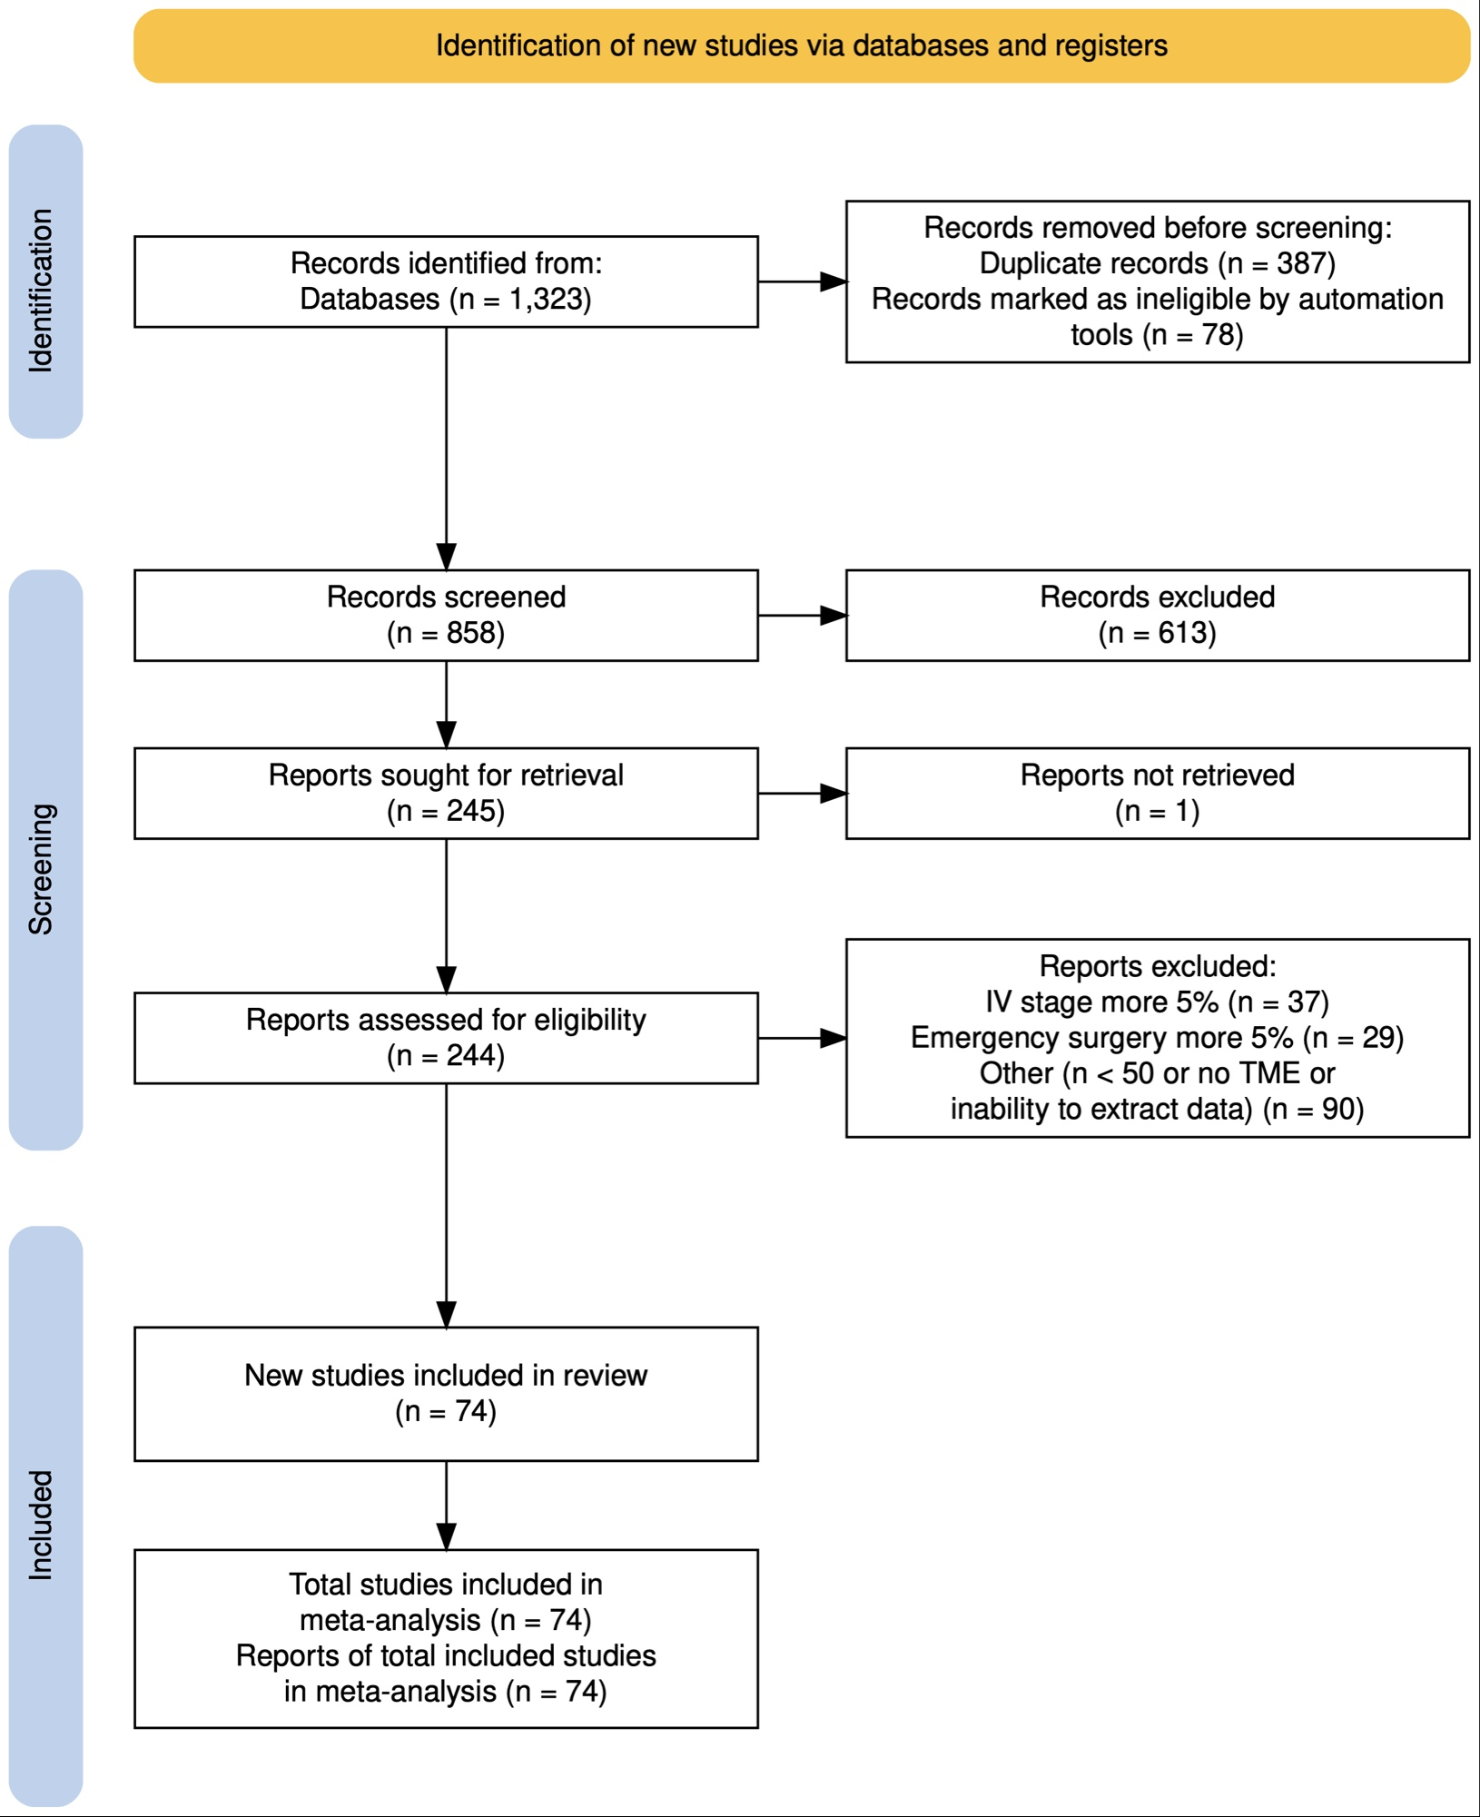

Figure 2
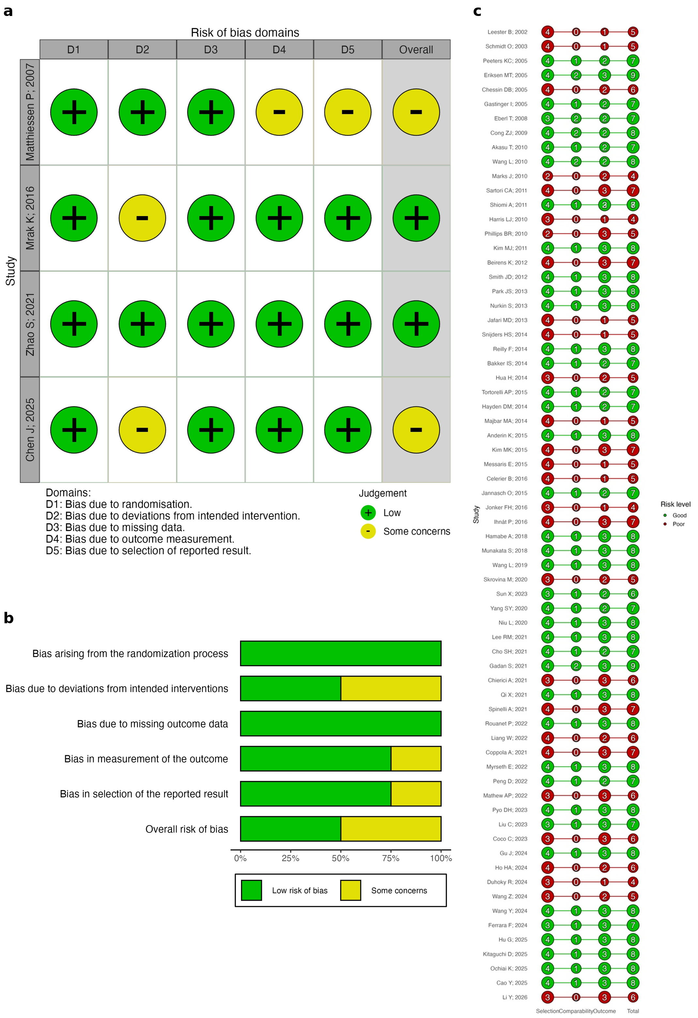

Figure 3
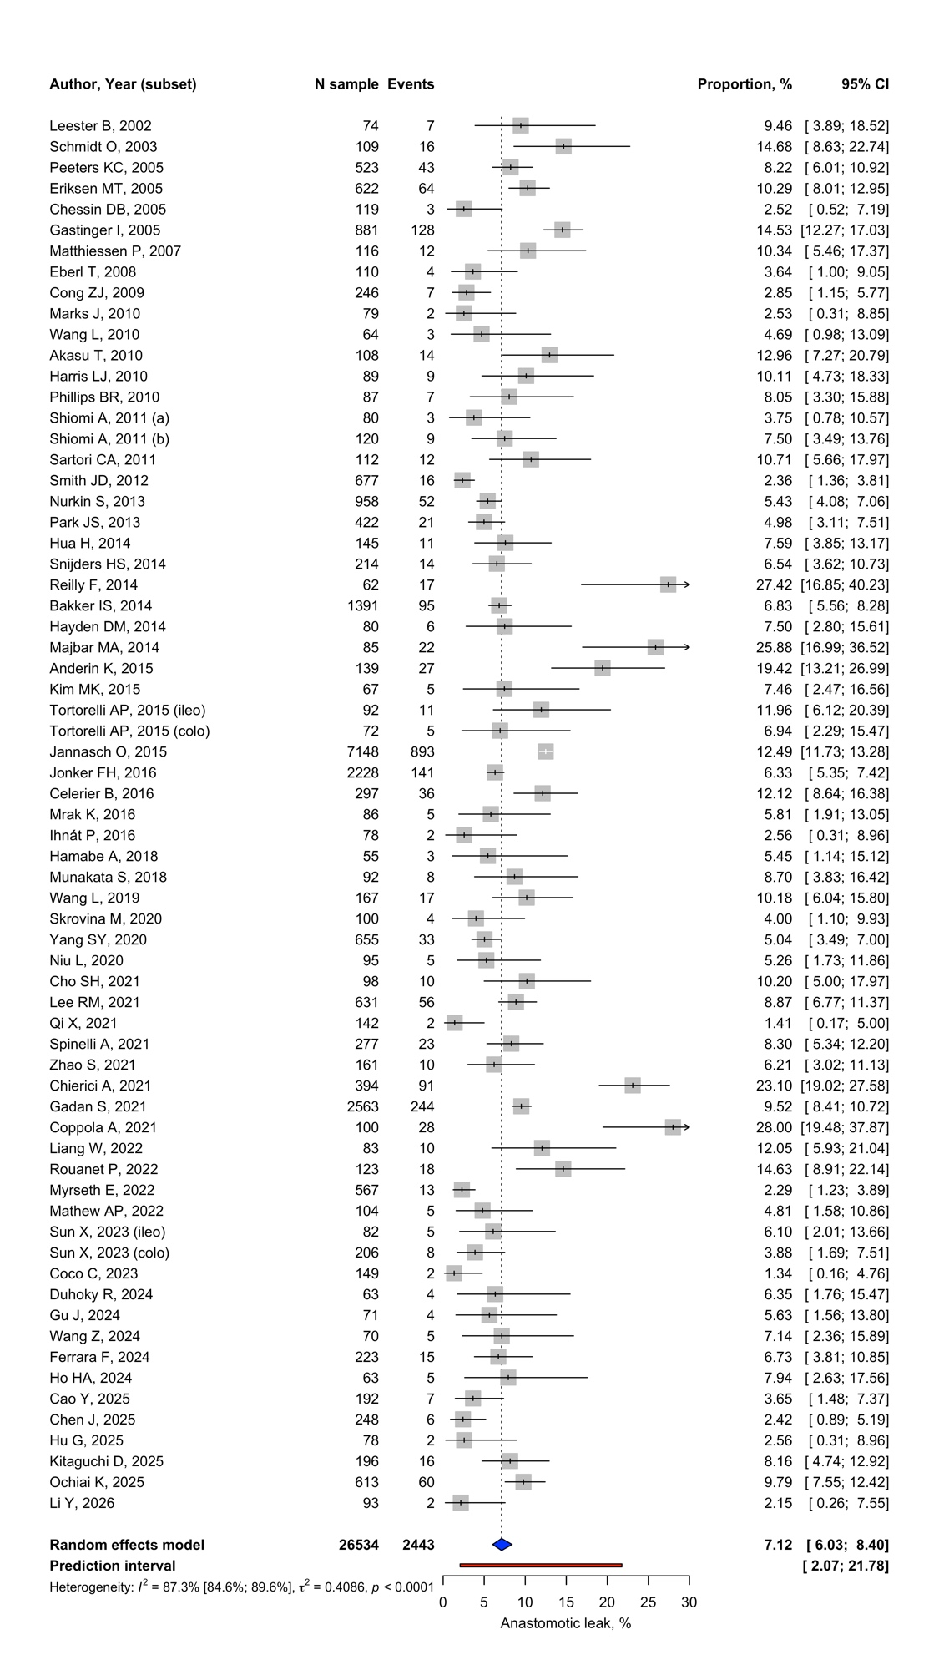

Figure 4
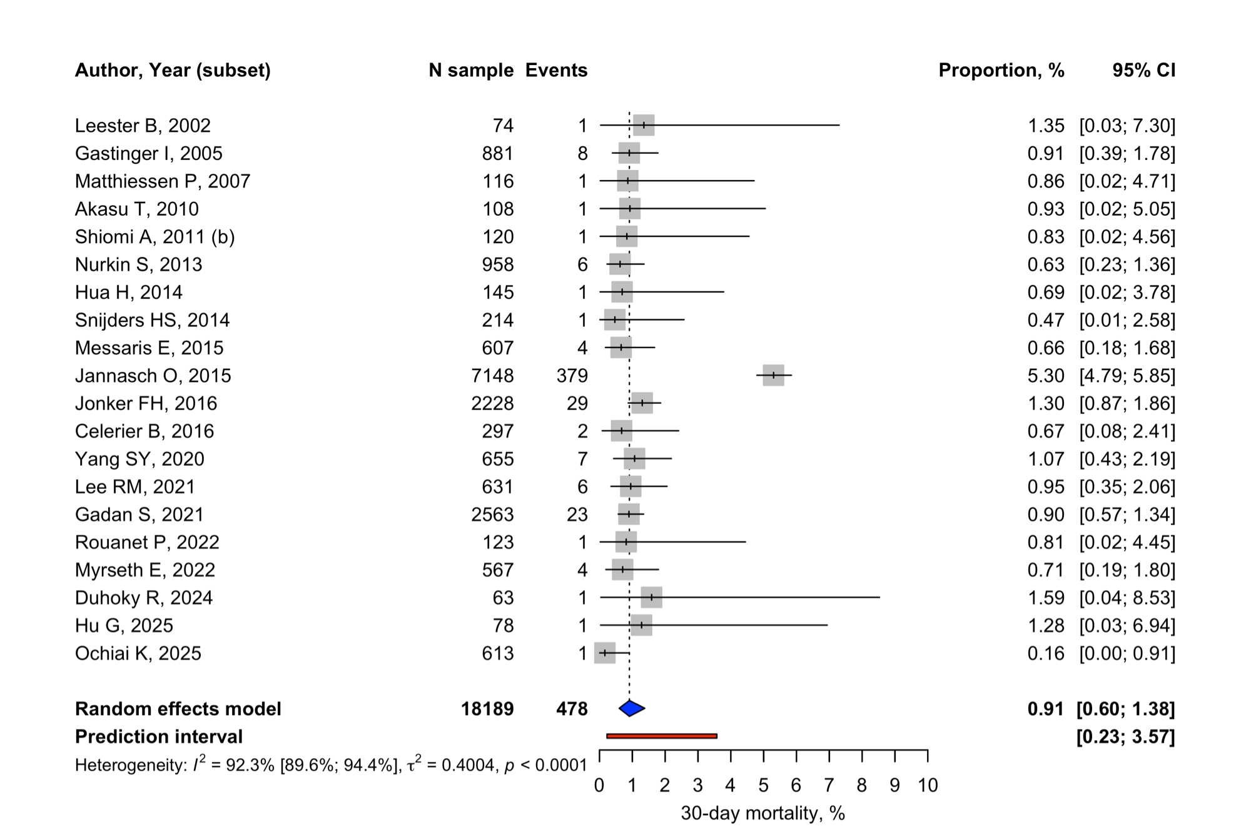

Figure 5
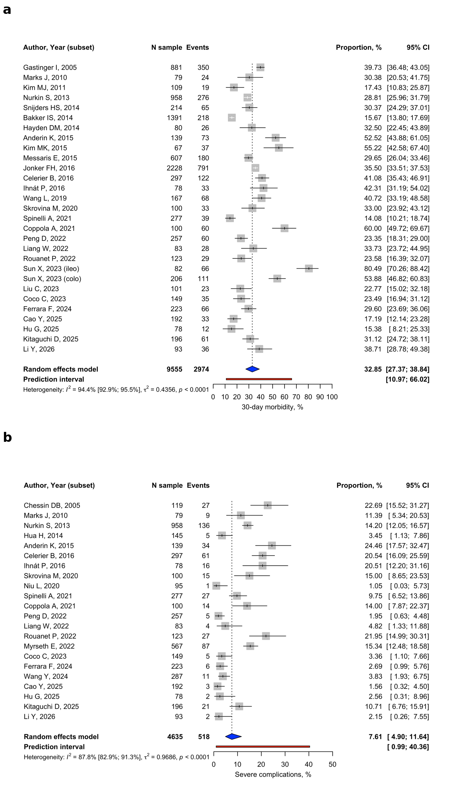

Figure 6


